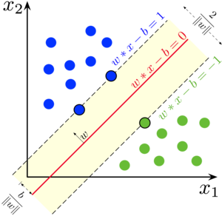

Document Algorithm

**SUPPORT VECTOR MACHINE**

***Support Vectort Machine (SVM)*** *are a set of supervied learning methods used for classification, regression and outliers detection.*

Hue, Brycen Co., Ltd

2020/10/05

Mục lục

[Mục lục ii](#_Toc52796251)

[Giới thiệu iii](#_Toc52796252)

[1 Ý tưởng 1](#_Toc52796253)

[2 Normative references *(mandatory)* 1](#_Toc52796254)

[3 Terms and definitions *(mandatory)* 1](#_Toc52796255)

[4 Clause title autonumber 2](#_Toc52796256)

[5 Clause title 2](#_Toc52796257)

[5.1 Subclause autonumber 2](#_Toc52796258)

[5.1.1 Subclause autonumber 2](#_Toc52796259)

[6 Clause title 3](#_Toc52796260)

[Annex A (informative) Annex title e.g. Example of a figure and a table 4](#_Toc52796261)

[A.1 Clause title autonumber 4](#_Toc52796262)

[A.1.1 Subclause autonumber 4](#_Toc52796263)

[A.1.1.1 Subclause autonumber 4](#_Toc52796264)

[Tài liệu tham khảo 6](#_Toc52796265)

Giới thiệu

Support Vector Machine là phương pháp học có giám sát và được sử dụng các bài toán phân loại mẫu. Rất hiệu quả với dữ liệu được phân tách tuyến tính mà còn tốt đối với dữ liệu phi tuyến tính. Trong một số bài toán, SVM còn sử dụng tài nguyên hiệu quả hơn so với mạng nơ-ron nhân tạo.

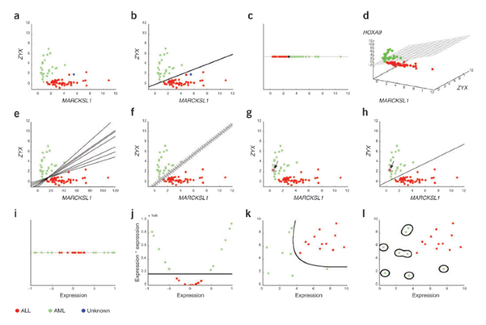

Hình 1. Các đường ranh giới quyết định và siêu mặt phẳng đươc vẽ bởi SVM.

# Ý tưởng

Type text.

# Normative references *(mandatory)*

*Two options of text (remove the inappropriate option).*

*1) The normative references shall be introduced by the following wording.*

The following documents are referred to in the text in such a way that some or all of their content constitutes requirements of this document. For dated references, only the edition cited applies. For undated references, the latest edition of the referenced document (including any amendments) applies.

ISO #####‑#, *General title — Part #: Title of part*

ISO #####‑##:20##, *General title — Part ##: Title of part*

*2) If no references exist, include the following phrase below the clause title:*

There are no normative references in this document.

# Terms and definitions *(mandatory)*

*Four options of text (remove the inappropriate options).*

*1) If all the specific terms and definitions are provided in Clause 3, use the following introductory text:*

For the purposes of this document, the following terms and definitions apply.

*2) If reference is given to an external document, use the following introductory text:*

For the purposes of this document, the terms and definitions given in [external document reference xxx] apply.

*3) If terms and definitions are provided in Clause 3, in addition to a reference to an external document, use the following introductory text:*

For the purposes of this document, the terms and definitions given in [external document reference xxx] and the following apply.

*4) If there are no terms and definitions provided, use the following introductory text:*

No terms and definitions are listed in this document.

*The list below is always included after each option:*

ISO and IEC maintain terminological databases for use in standardization at the following addresses:

— ISO Online browsing platform: available at <https://www.iso.org/obp>

— IEC Electropedia: available at <http://www.electropedia.org/>

3.1

term

text of the definition

Note 1 to entry: Text of the note.

[SOURCE: …]

3.2

term

text of the definition

# Clause title autonumber

Type text.

# Clause title

Type text.

*Use subclauses if required e.g. 5.1 or 5.1.1. For example:*

## Subclause autonumber

### Subclause autonumber

*There are two options for providing formulae: Equation Editor in MS Word, or MathType Equation.*

Example of formula in MS Equation Editor:

$$K_{2A}=10\log\left(1+\frac{4S}{A}\right)$$

where

|  |  |  |
| --- | --- | --- |
|  | *A* | is the equivalent absorption area of the room, in square meters; |
|  | *S* | is the area in square meters of the measurement surface (in the case of this procedure, *S* is a sphere with a radius of 1 m, i.e. *S* = 4*π*). |

The same formula in MathType Equation:



# Clause title

Example of codes:

<xs:complexType name="Route">

 <xs:sequence>

 <xs:element name="routeID" type="tdt:IntUnLoMB"/>

 <xs:element name="routeListID" type="tdt:IntUnLoMB"/>

 <xs:element name="listCount" type="tdt:IntUnLoMB"/>

 </xs:sequence>

</xs:complexType>

1. (informative)  
     
   Annex title e.g. Example of a figure and a table
   1. Clause title autonumber

*Use subclauses if required e.g. A.1.1 or A.1.1.1. For example:*

* + 1. Subclause autonumber
       1. Subclause autonumber

Type text.

Dimensions in millimetres

figure_exemple

**Key**

|  |  |  |  |
| --- | --- | --- | --- |
| 1 | desiccant/aqueous saturated salt solution |  |  |
| 2 | test specimen |  |  |
| 3 | sealant |  |  |
| 4 | template |  |  |

NOTE Figure note.

|  |  |
| --- | --- |
| a | It is the upper exposed area. |
| b | It is the lower exposed area. |

**Figure A.1 — Example**

**Table A.1 — Example**

|  |  |  |  |  |
| --- | --- | --- | --- | --- |
| **Type** a | **No. series** | **Pressure** | **Length** | **Temperature** |
| *p*1 | *l*2 | *T*1 |
| MPa | mm | °C |
| A | 248-i | 50 | 216 | 50 |
| B | 556-i | 100 b | 287 | 60,5 |
| C | 43-ii | 200 | 300 | 38 |
| NOTE   Table note.  a   Table footnote.  b   Second table footnote. | | | | |

Tài liệu tham khảo

1. [ML] Support Vector Machine – SVM, URL: <https://dominhhai.github.io/vi/2018/03/ml-svm/>